Name: Kanak Agrawal

Email: [kanakagrawal2001@gmail.com](mailto:kanakagrawal2001@gmail.com)

Date: 10-02-2024

Day -15 Assignment (Pysaprk)

* **Pyspark SQL for Group By and Agrregate Function**

1. **Count**

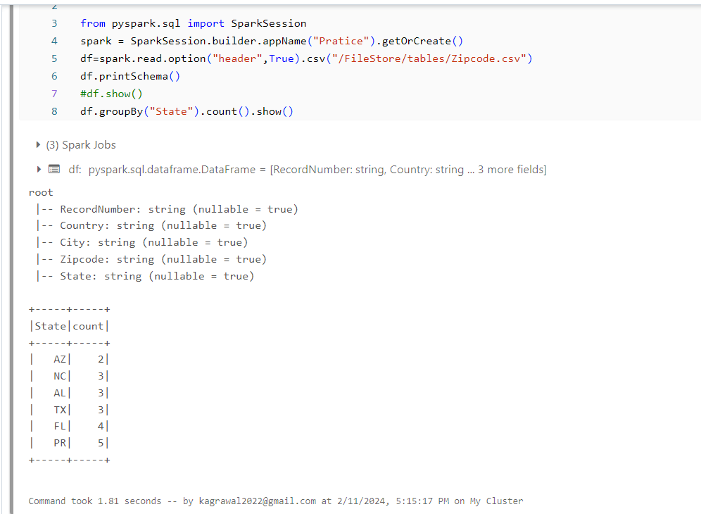

1. **Minimum**

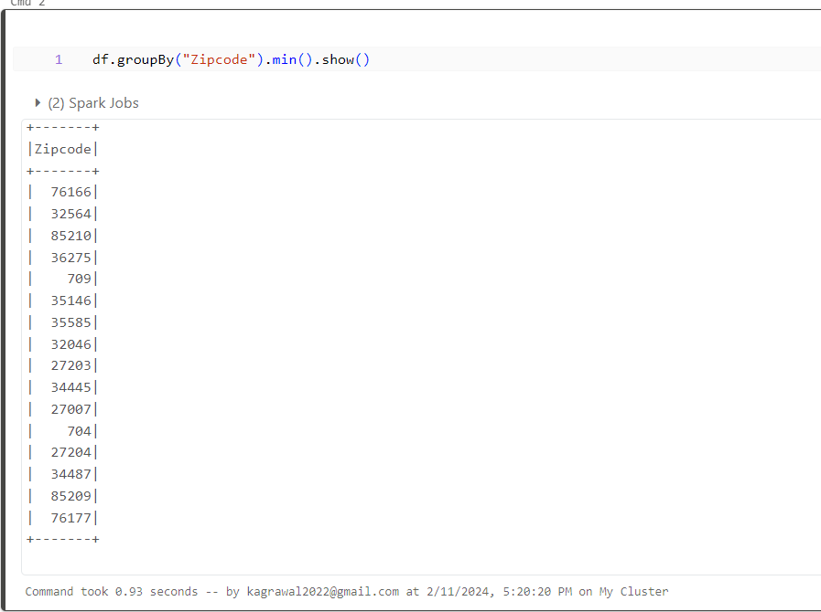

1. **Maximum**

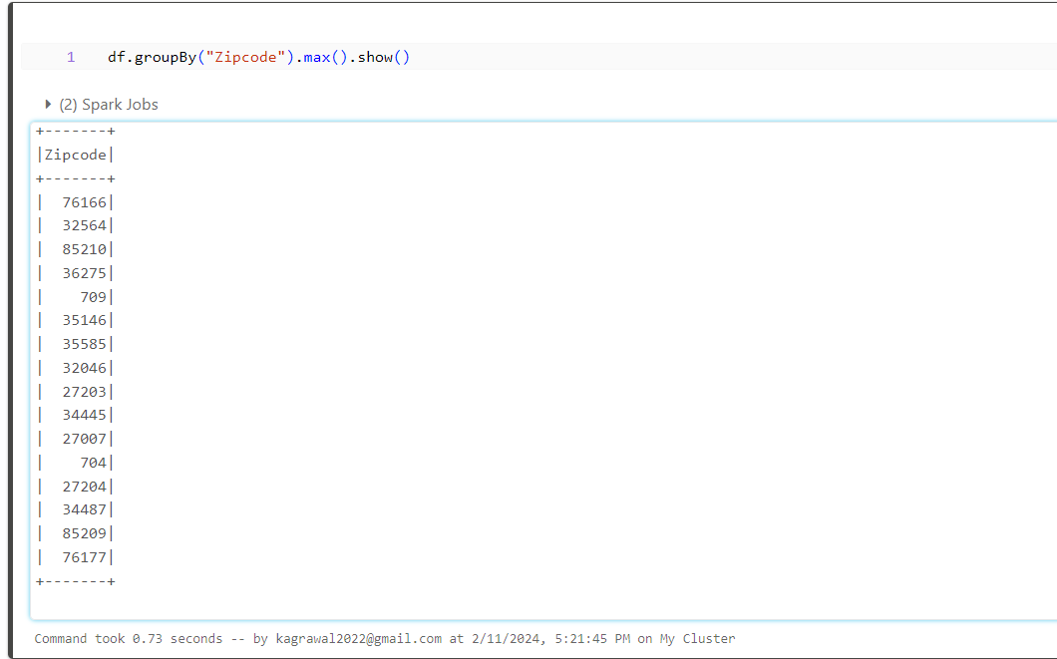

* **Filter in pyspark Sql**

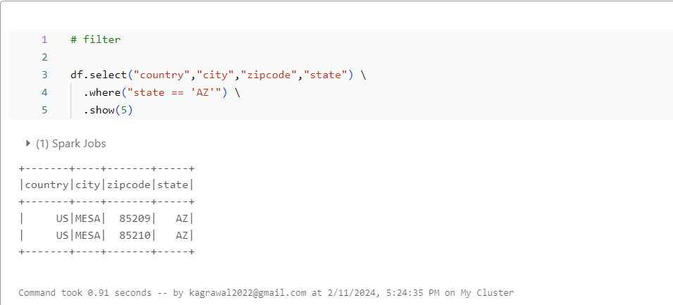

* **Joins**

1. **Inner Joins**

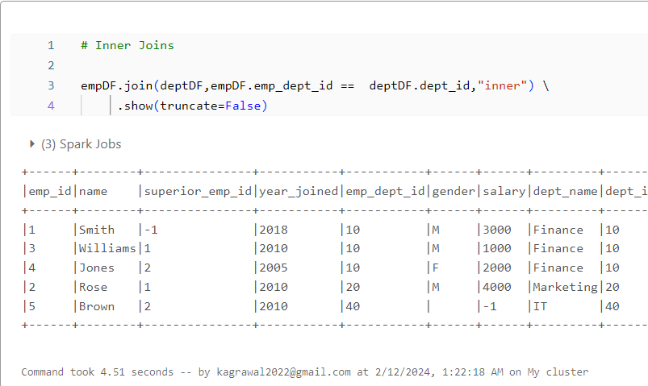

1. **Full Outer Joins**

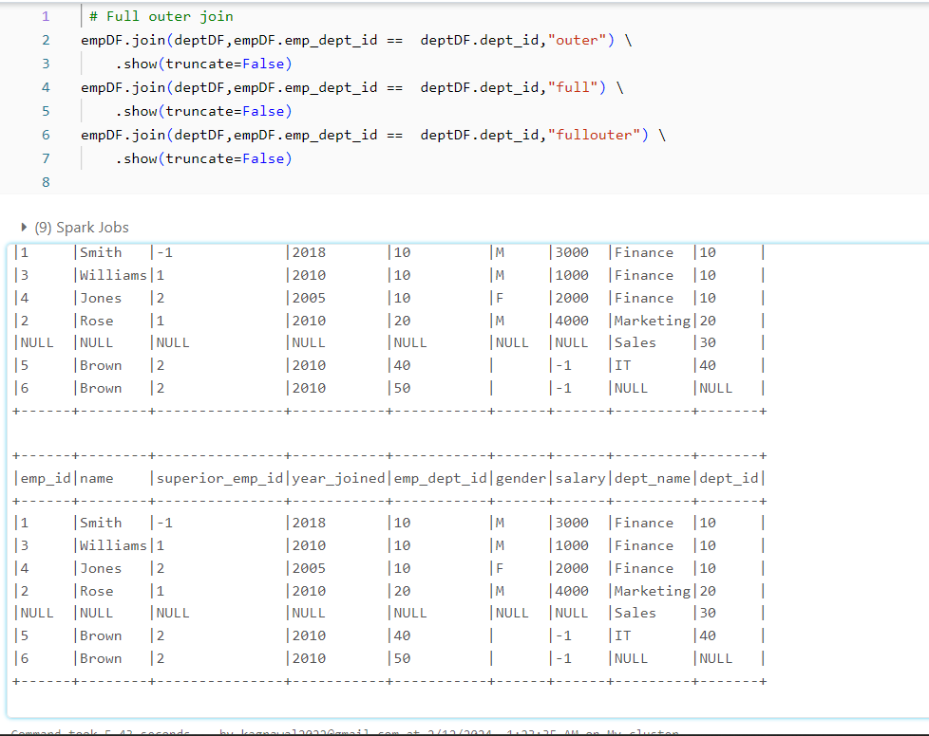

1. **Left Joins**

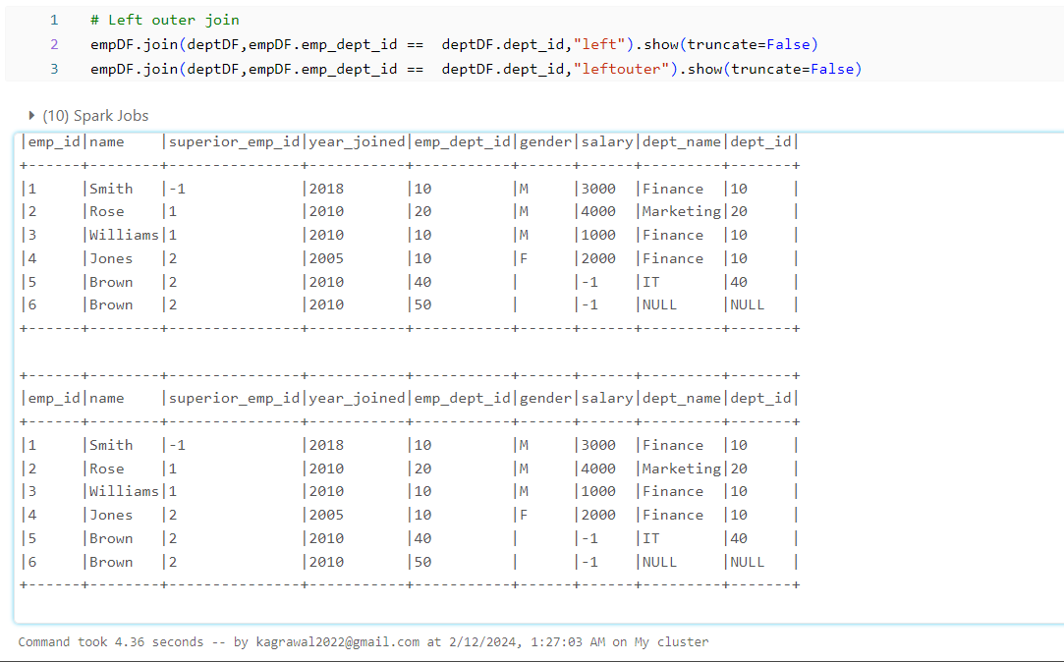

1. **Right Joins**

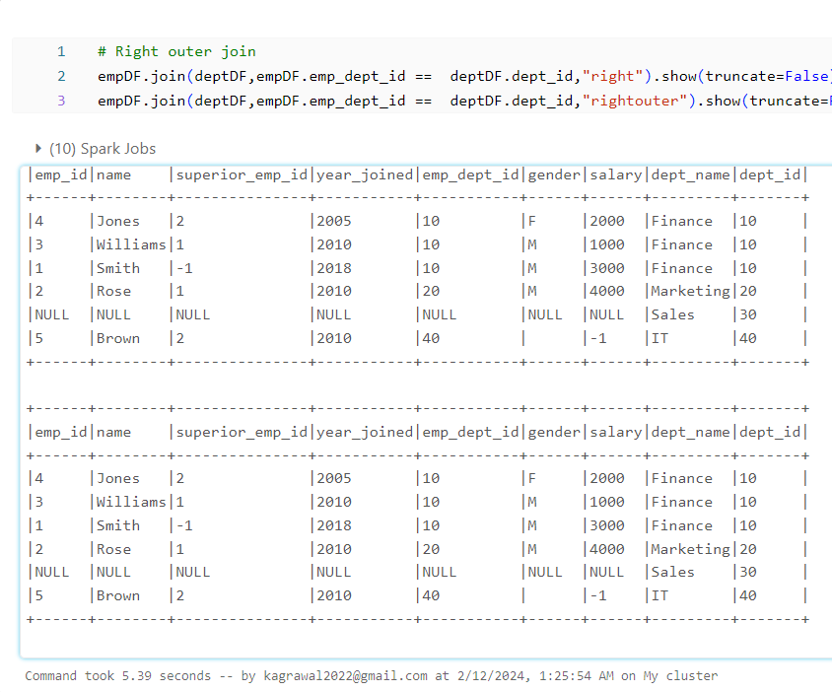

* **UNIONS**

1. **Union**

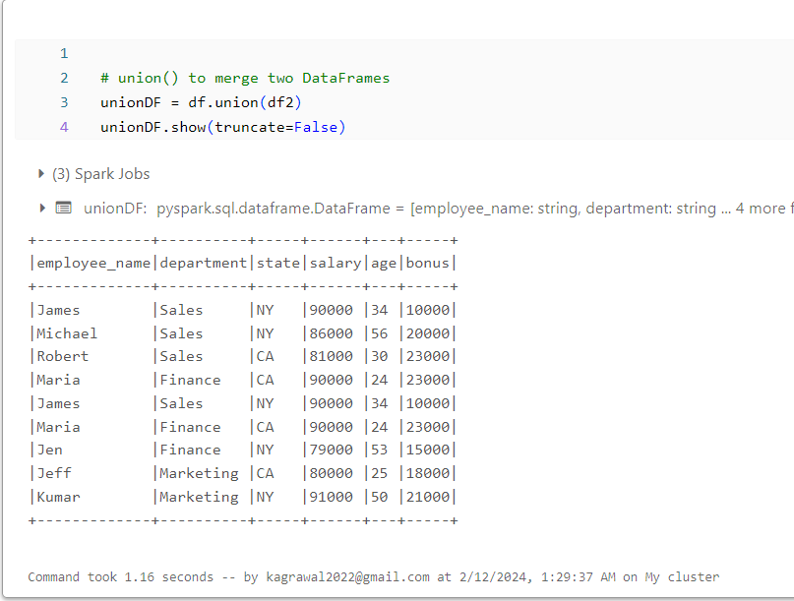

1. **Union All**

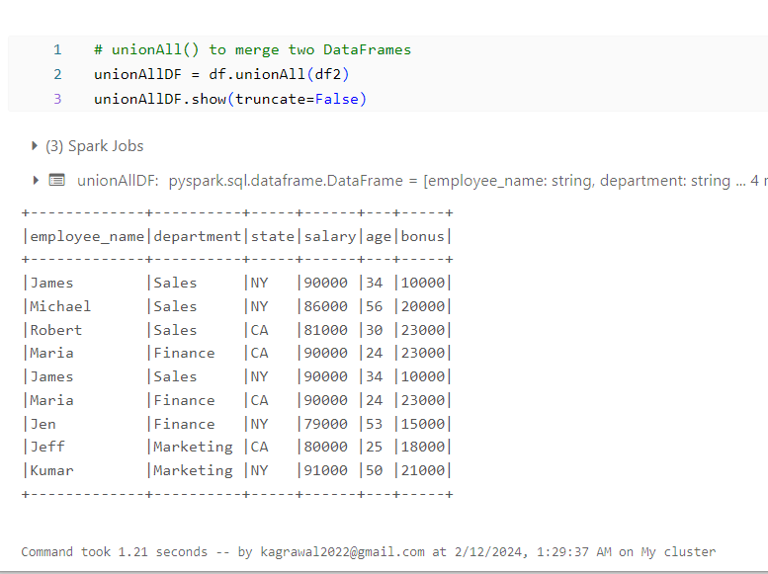

1. **Remove duplicate after union**

